Introduction for Project B

**Aim of this project:** Create a simple Linux C based application that demonstrates application that uses a database.

**Description:** a simple system can insert one record of student information to a database.

**Design of the system:**

1. **Database:**

**Platform:** MySQL 8.0

**Data base structure:**

**Table:** Students

|  |  |  |
| --- | --- | --- |
| **id**  *Data type:*  INT PRIMARY KEY AUTO_INCREMENT | **name**  *Data type:*  VARCHAR(255), | **age**  *Data type*:  INT |
| 1 | Mike | 11 |
| 2 | Joe | 12 |
| 3 | Amy | 11 |

1. **Database setup**

1: Create a database with the name: testdb

***Command***: mysql>CREATE DATABASE testbd;

2: Setup the database via saved SQL script: testdb.sql

***Command***: mysql -u yourusername -p testdb<testdb.sql;

By using following command, you will find the database with one table (Students) to record the student information, initially, there are 3 student records.

***Commands:***

1, mysql -u yourusername -p

2, mysql> use testdb;

3, mysql> show tables;

4, mysql> select * from Students;

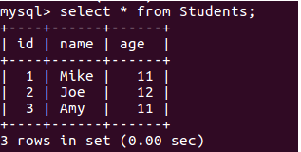

**Code description:**

The code example can be divided into these parts:

1. Initiation of a connection handle structure

*MYSQL *con = mysql_init(NULL);*

1. Creation of a connection

*if (mysql_real_co****nnect(con****, "localhost", "yu", "123", "testdb", 0, NULL, 0) == NULL)*

1. Execution of a query

*if (mysql_query(con, "INSERT INTO Students VALUES(4,'Jake',10)"))*

1. Closing of the connection

*mysql_close(con);*

**Compile and run**:

**Command**： gcc -I/usr/include/mysql Test_MYSQL.c -L/usr/lib/x86_64-linux-gnu -lmysqlclient -o Test_MySQL

**Please note:** the path for head files such as *mysql.h (-I/usr/include/mysql),* and the compiled library path for *lmysqlclient.so ( -L/usr/lib/x86_64-linux-gnu -lmysqlclient)* shoud shoud be indicated here for the compole process.

In will generate the executable file: Test_MySQL.

Run the file by **command**: ./Test_MySQL

A message will appear:

---->Connect to MySql successful!<----

Records inserted

When come back to the mysql tool, use the command: ,mysql> select * from Stdents;

you can find a new record (4,'Jake',10) has been added.

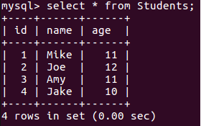

**Further test:**

You can also add more record by modify the code of *line 26* as:

if (mysql_query(con, "INSERT INTO Students VALUES(5,'Kate',15)")),

Then save and compile the source file run the application via the aforementioned commands, you can find a new record (5,'Kate',15) has been added.